Step 1. Go to “www.github.com/patsonluk/airline” and download the zip file.

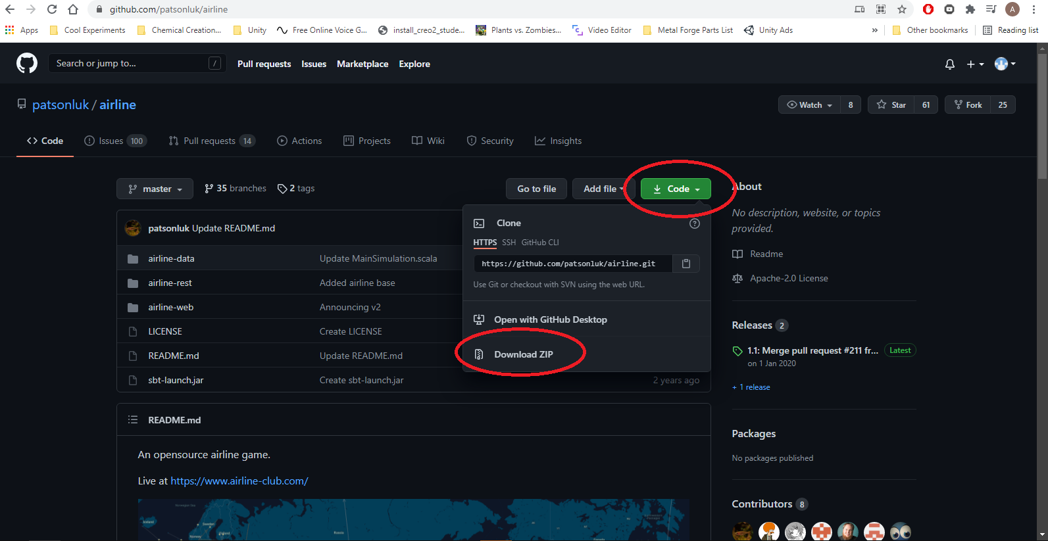

Step 2. Download the java JDK from oracle. Unfortunately, oracle demands that you sign up to download it, but you can just use a fake email generator if you don’t want to use your own email: “https://www.oracle.com/java/technologies/javase/javase-jdk8-downloads.html”

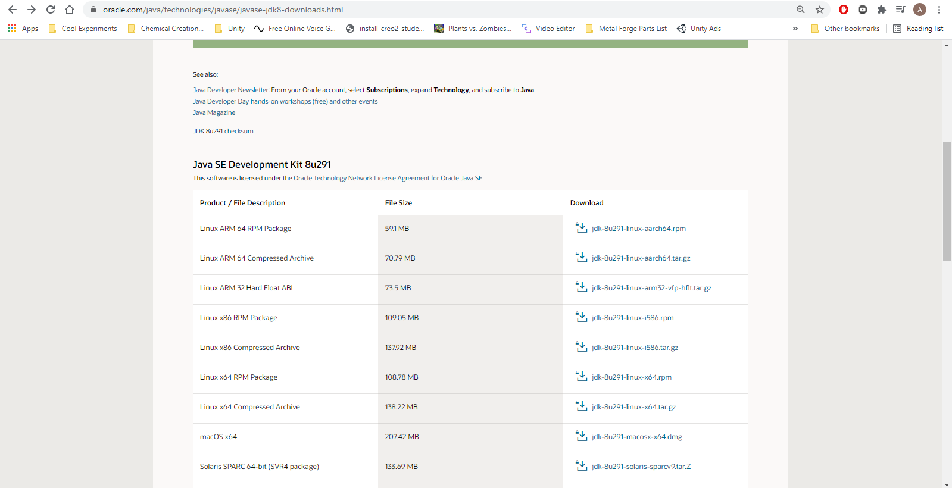

Step 3. Download mysql. Make sure that the version you get starts with “5.7” (Shouldn’t matter which subversion), as we are still unsure if the latest version 8 actually works or not. We will continue this once it’s finished downloading in step 6: “https://downloads.mysql.com/archives/community/”

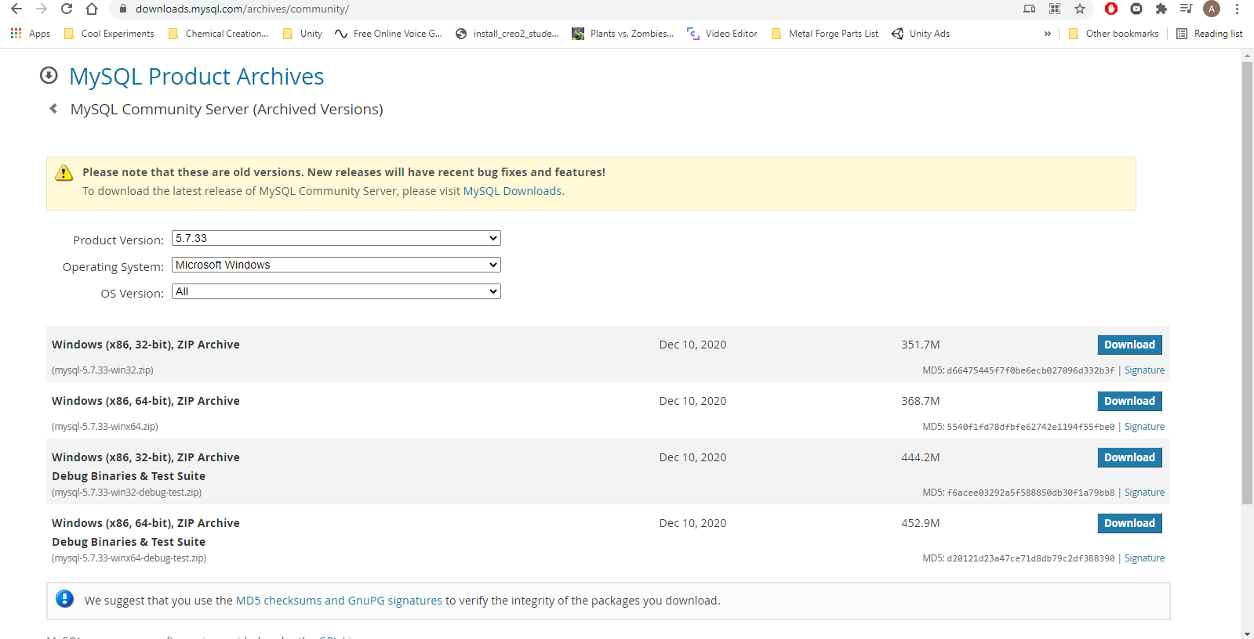

Step 4. Install mysql workbench. You’ll only need this to run a single command once. Unlike mysql, it doesn’t matter which version you get: “https://dev.mysql.com/downloads/workbench/”

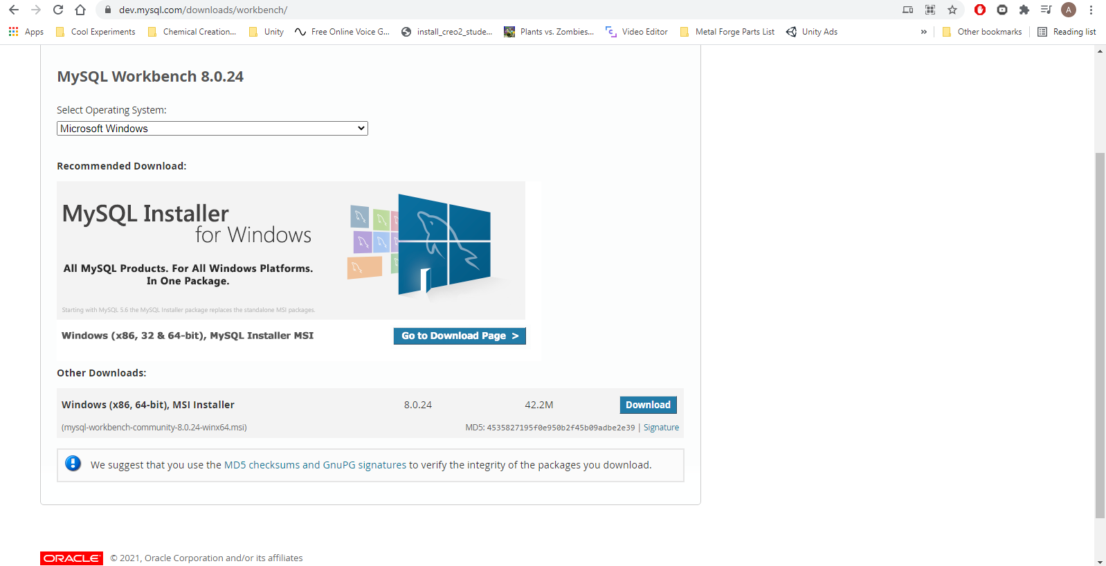

Step 5 (Optional). Download elasticsearch. This is entirely optional, and juust makes the search function in the server work a bit better. Here is the link for installing: “https://www.elastic.co/guide/en/elasticsearch/reference/current/install-elasticsearch.html”

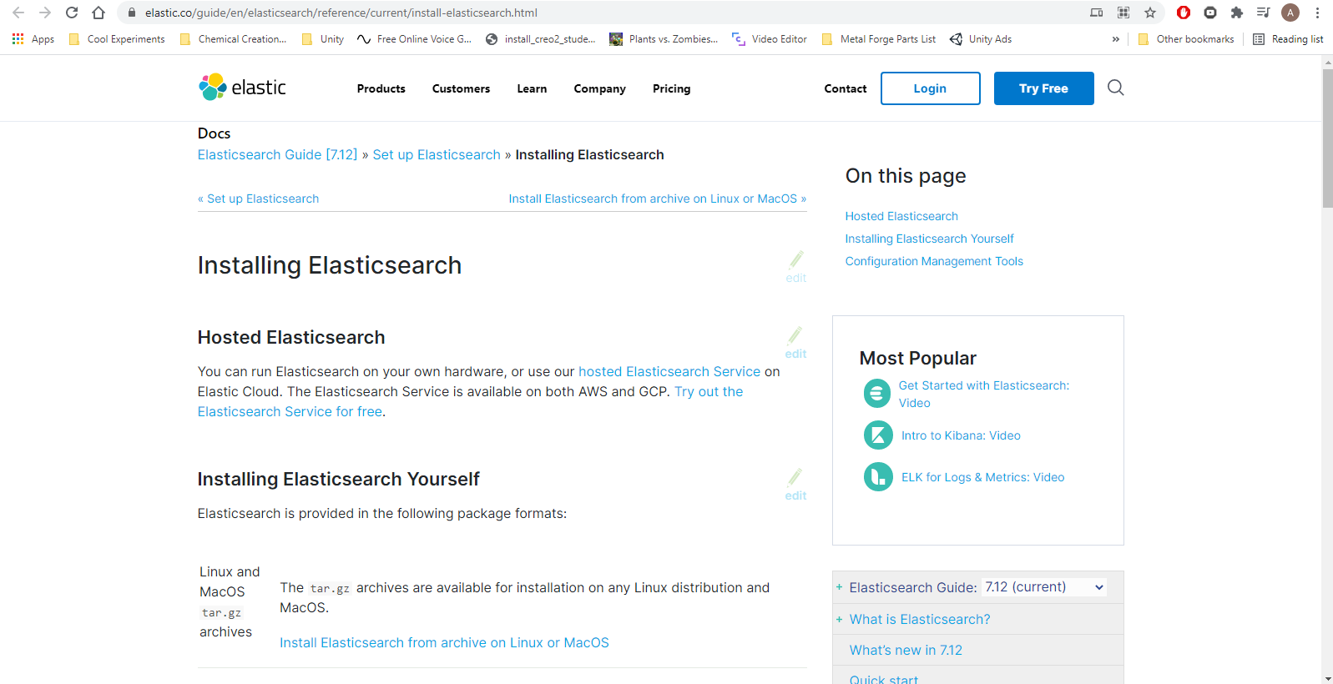

Step 6. Setup the environment variables. Go to the folder that you opened in step 3 and unzip Move the unzipped folder somewhere you want it to be kept on your system. Personally I put it on my spare drive, but you can leave it in your downloads folder if you wish. Now that you’ve moved it where you want, inside the file is a folder called the same thing. You want to open that up. Now comes the complicated part. You want to go to the top of the folder and copy that directory path. It will probably look something like “C:\Users\aj200\Downloads\mysql-5.7.33-winx64\mysql-5.7.33-winx64”, but might be a bit different if you moved it.

Open up the windows search bar down the bottom left, and type in “environment variables”. There should be something called “Edit the system environment variables”, open it up.At the bottom right of the popup, select “Environment Variables”. You should see two sections, you want to check the top section “User variables for YOUR_USERNAME_HERE” (I have highlighted in brown in the picture), and select the variable called “Path”. Just under the top panel is a button that cays “Edit”, so click that. On the right of the new popup, select “New”, and in the text field type “%MYSQL_HOME%\bin”. Please note, in the image I spelt it wrong. Then juust hit “Ok” to go back to the previous screen.

Now that you are back at the environment variables screen again, look at the bottom area (I have highlighted in blue), and hit the “New” button. Set the “Variable Name” to “MYSQL_HOME”, and the variable value to the directory we copied earlier in the step. While we are here, also check that the variable “JAVA_HOME” exists like in the image. If it does, then you are ready for the next part. If not, then go to “C:\Program Files\Java” and open the folder that has “jdk” in it’s name. Ignore any folders with “JRE” in them, as that is different. Copy that directory, and perform the same step to add “JAVA_HOME” to your system variables, with the value as the copied directory.

ONLY IF YOU DOWNLOADED ELASTISEARCH: Unzip the folder. Inside should be a directory called “bin”. open that up, and copy that directory. Go into “System variables” just as before, select “Path”, and click “edit”. Now that we are looking at the “Path” variable, we want to hit “New” on the right, and type in the directory we juust copied. Mine looks like this: “F:\elasticsearch-7.12.0\bin”, but of course yours will look different depending on where you put the unzipped folder.

You can now hit ok and get out of that screen, the complicated part is finished! This was the hardest and most complicated step

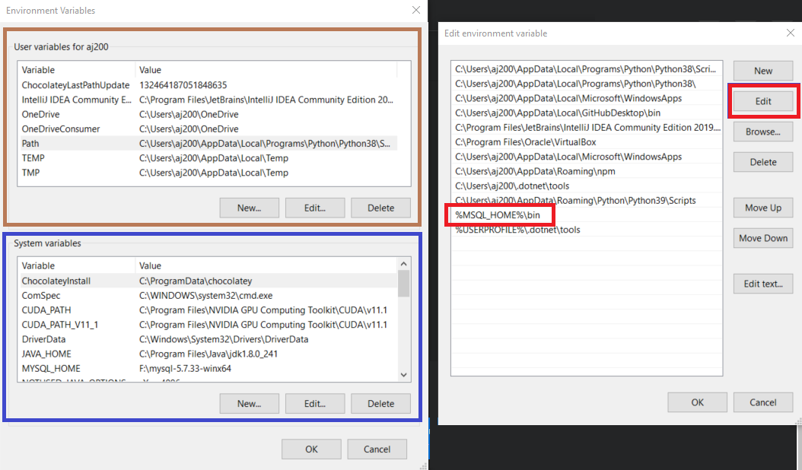Step 7. Start mysql. To do this is pretty easy. Go to windows search bar and type “cmd”. There will be a program called “Command Prompt” pop up. Right click it and go to “Run as administrator”. Now in the terminal window that pops up, type in “mysqld --skip-grant-tables --console”. It will spit out a bunch of text to the screen, but that’s ok. You will want to keep this window open for the next handful of steps, but you can minimise it for now as it only needs to run in the background.

Step 8. Run “mysql workbench”. Different versions look very different, I’m using version “8.0”. You’ll want to create a new “Connection”, call it whatever you want, and then set the following parameters:  
 - Hostname: “127.0.0.1”

- Port: “3306”

- Username: “sa”

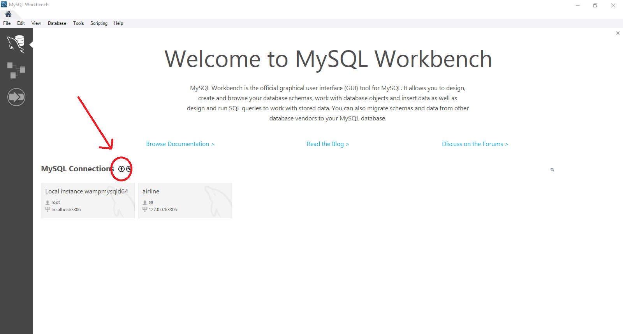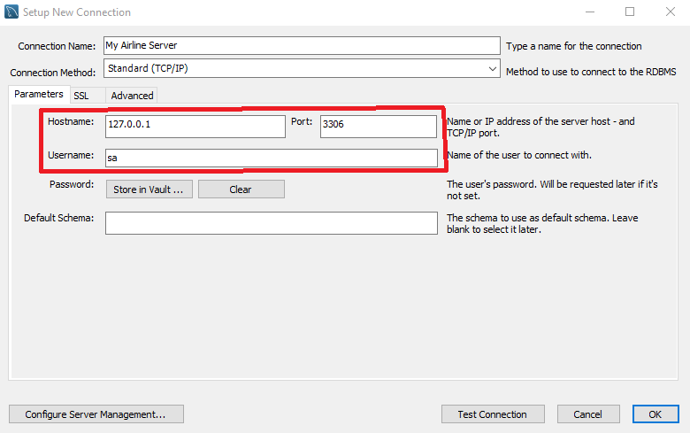

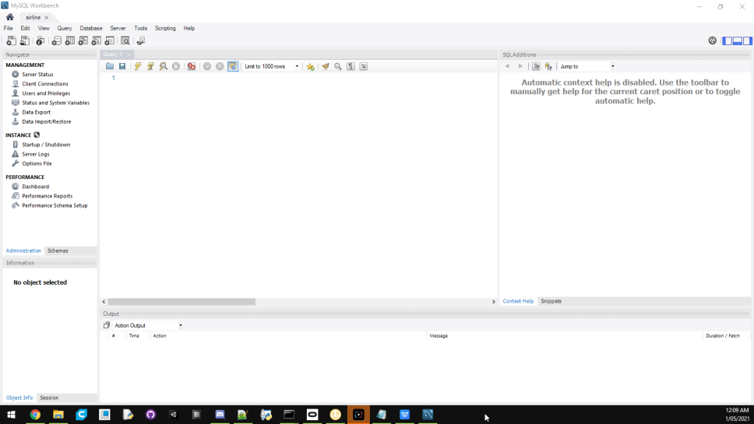

Step 8. Here is the tricky part. In MySQL Workbench, in the “Query” window, type in The following:  
ALTER TABLE `airline`.`link` ADD COLUMN `airplane_model` SMALLINT NULL AFTER `flight_number`;

In a moment, we are going to want to hit the little lightning bolt symbol up the top of the tab, but not yet. There is something we need to do first. Open up another command prompt window like we did in step 7. This time, type in the command as seen in the image. I put my “airline-master” file from step 1 into my F drive, but change the command directory to where-ever you kept your server file. Note that I also added “airline-data” to the end of the directory. You want to do that as well.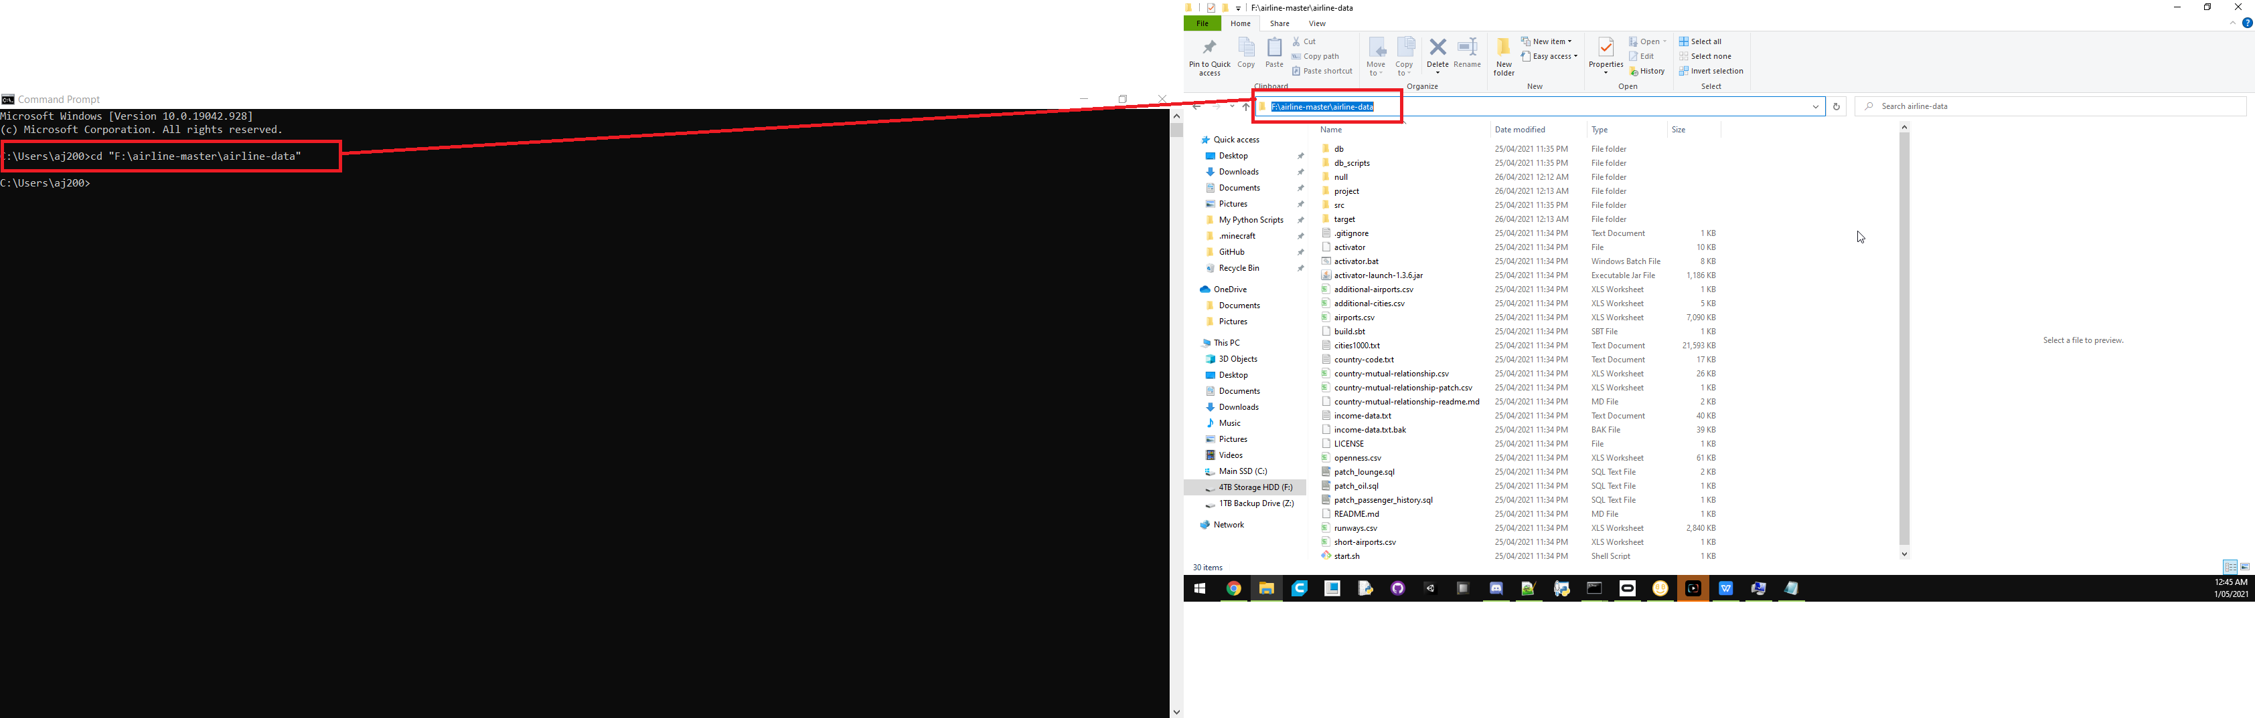

Step 9. Just before we continue, there is a tiny edit you need to make. In the server files, go to “airline-web”, “app”, “controllers”, and in there open up a file called “SignUp.scala”. On line “140” there is a function called “isValidRecaptcha”. On the line just after that, we want to add “ return true; ”. This just prevents recaptcha issues later on in step 11. I’ve shown the edit in the image.

in that command prompt window we just made in step 8, you now want to type in “activator publishLocal”. Give it some time to finish. Once it’s finished, then type in “activator run”. Give it a minute and it will come up with a handful of options. Type in “12” and hit enter. Don’t worry if the numbers don’t show up on screen when you type them, it does that for some reason. Now is the tricky part. You want to get ready. Watch the command prompt window, and it will start throwing a ton of text onto the screen. This is completely normal. We are waiting for a line that says something like “Generating Guassian” on it’s own. It will probably pause here for a bit. When you see this, quickly jump over to mysql workshop that you still have up from step 8 and hit that lightning bolt symbol! You’ll know if it worked within a few seconds.

If it worked, then the code will continue on working. Leave it to do it’s thing. You can close mysql workshop now. Wait for the code to finish up what it’s doing (This may take quite some time). Once it’s done, you are ready to start everything up. Feel free to restart your computer if you want, but I didn’t need to. 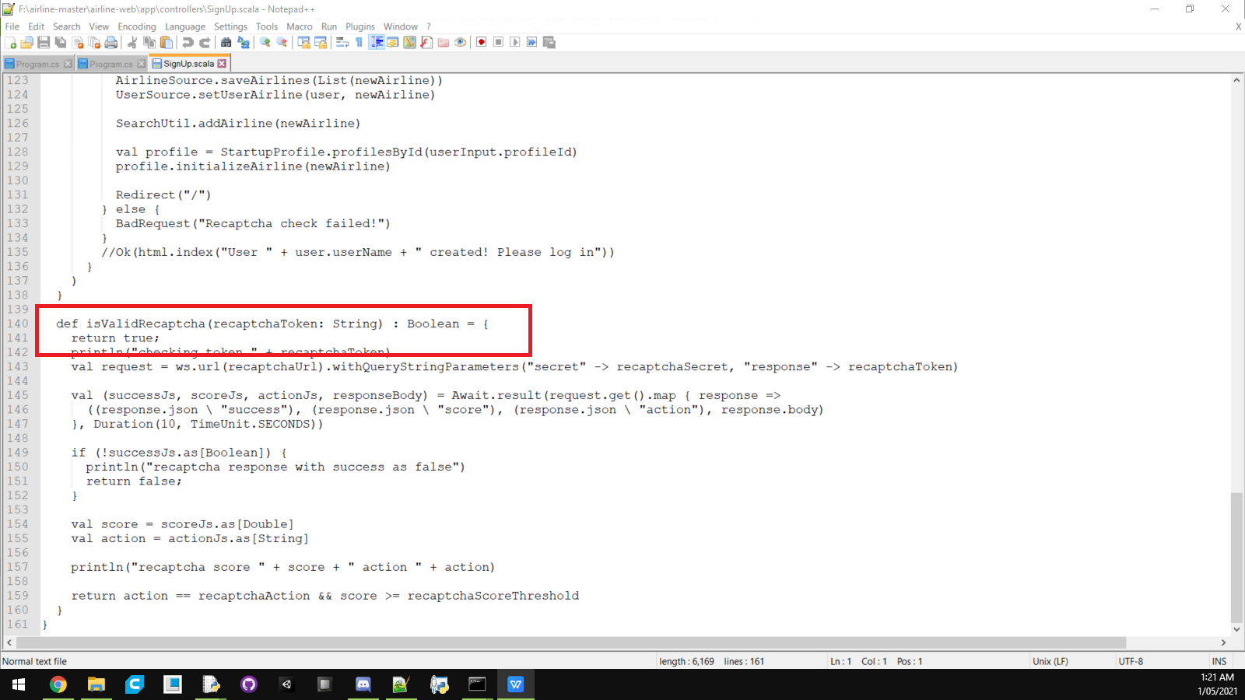

Step 10. Finally start the server! For this, you will want to open up 4 different command prompt screens. I know, I wish it could all be done in one, but bear with me:  
  
In command prompt terminal 1, type in “mysqld --skip-grant-tables --console” just like in step 7. This will run in the background

(Only if you downloaded elastic search) In command prompt terminal 2, type in “elasticsearch”. This will also run in the background.

In command prompt terminal 3,run the same command we did at the end of step 8. Then type in “activator run”. This time, we want to select option “1”, not “12”. Give it some time to boot up. Usually 5 minutes is more than enough for it to boot up. This will run in the background.

In command prompt terminal 4, wait for command prompt terminal 3 to complete it’s thing, or it will fail. Once ready, run the same command we did at the end of step 8, except instead of adding “airline-data” to the end of the directory, instead do “airline-web”. Like before, type in “activator run”. Give this a bit of time to boot. Usually 2 minutes will do.

With these 4 command prompt windows all running in the background, the server is actually up and running.

Step 11. Finally connecting to the server. Open up any browser (Chrome, firefox, microsoft edge, etc), and type in “localhost:9000”. If everything works, you should be greeted with the server screen. If someone else wants to join, you’ll have to port forward your modem. If you need help with that, we would be happy to help.

S. Technically this should work just fine, but there is an issue with the map screen by default. We can show you how to fix that bug, it’s fairly straight forward.